PPE admissions 2021-22
Information for applicants

Section 1: admissions statistics
This year the number of applicants was 1994. The number of applicants per place was 8.3. There were 357 open applications and 43 deferred entry applications. There were 873 female and 1121 male applicants. There were 989 home, 301 EU and 704 overseas applicants. 733 applicants were shortlisted and 264 were offered places.

Section 2: admissions processes

The selection criteria for PPE are on the course website. The shortlisting criteria are described on the course website as follows: “We only interview those who have a realistic chance of getting in, when judged by past and predicted exam results, school reports, personal statements and the pre-interview test. Applicants who do not take the pre-interview test will not normally be shortlisted for interview.”

Colleges are set deselection targets so that across all colleges at least 2.75 applicants per place are shortlisted. When making shortlisting decisions admissions tutors give the following weighting to the various elements of each application.

Information | High | Medium | Low
Pre-Interview Admissions Test | Yes
GCSE (or equivalent) profile | Yes
Predicted (or actual) performance at  A-Level (or equivalent) | Yes
UCAS teacher’s reference |  | Yes
AS-Level module grades |  |  | Yes
UCAS personal statement |  |  | Yes

See section 4 for graphs on the GCSE scores and A-Level scores of applicants at different stages.

After colleges have deselected their target number of applicants, some shortlisted applicants are reallocated. They are sent to the available college where they will have the best theoretical chance of success, based on TSA section 1 scores. After the reallocation has taken place colleges can choose to rescue deselected applicants.

Section 2.2: interview process

Applicants will normally have at least two interviews at their first college, although some colleges may have a single longer interview. Most colleges will have a minimum of two interviewers per interview. Colleges normally wish to involve tutors from all three subjects, but since there are no specific subject requirements, this is not necessarily the case.

The interview is described on the course website as follows: “The interview is not primarily a test of existing knowledge. It is aimed primarily at assessing the candidate’s potential for future development. Interviewers will be looking for evidence of the candidate’s potential for development in the following four areas:
Understanding: this can be shown in (for example) a candidate’s ability to listen carefully, to analyse problems, to identify the premises and conclusions of arguments, and to express in their own words someone else’s ideas.
Intellectual flexibility: this can be demonstrated by (for example) a candidate’s willingness to consider alternative views, and readiness to respond to problems and criticisms.
Critical thinking and problem-solving: this can be shown in (for example) a candidate’s ability to adopt logical and critical approaches to problems, to critically assess arguments, to identify good and bad reasons for believing a particular claim, to assess relevance, and to think independently.
Communication: this can be shown in (for example) a candidate’s ability to express ideas clearly, to give considered responses to questions, and to address the point under discussion instead of veering off topic.”

Colleges assign candidates up to three interview scores. These do not have to be subject-specific. Interviews are marked on a 1-100 scale:

70-100 | Excellent | A mark above 70 is a strong indicator for admission
65-69 | Positive | Most candidates admitted will have interview scores above 65.
60-64 | Neutral
50-59 | Weak | A candidate with interview and test marks consistently below 60 is in a weak position
49 or less | Very poor | Interview strongly suggests that the candidate is not suitable

After colleges have entered their first interview scores and decisions candidates are ranked according to a post-first interviews score which is based on interview scores and TSA scores. Colleges then select second interviews using all information available for each candidate.

This year 24 candidates were selected for second interviews. After second interviews have taken place colleges make their final decisions based on all information available for each candidate at this stage.

Section 3: pre-interview admissions test

TSA results are released on 11 January 2022. They can be accessed via Cambridge Assessment’s Results Online system. The average test performance of applicants at the different stages is set out in the graphs in section 4.

Section 4: graphs

GCSE grades: 9/8/A* count

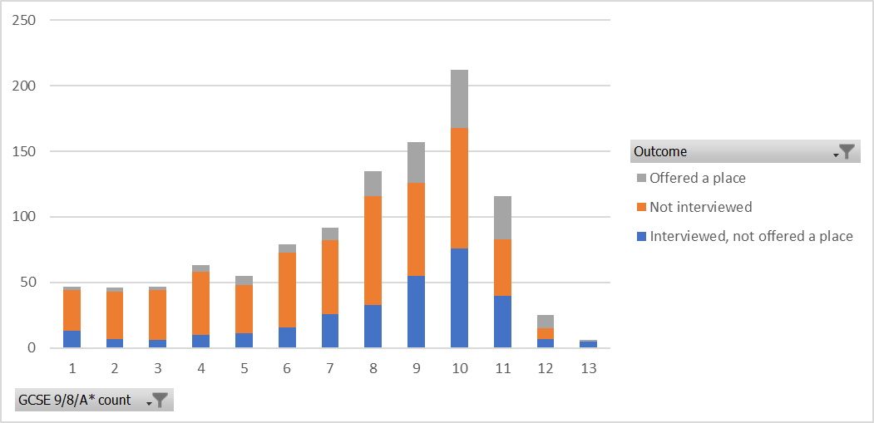

Predicted or achieved A Level grades: A* count

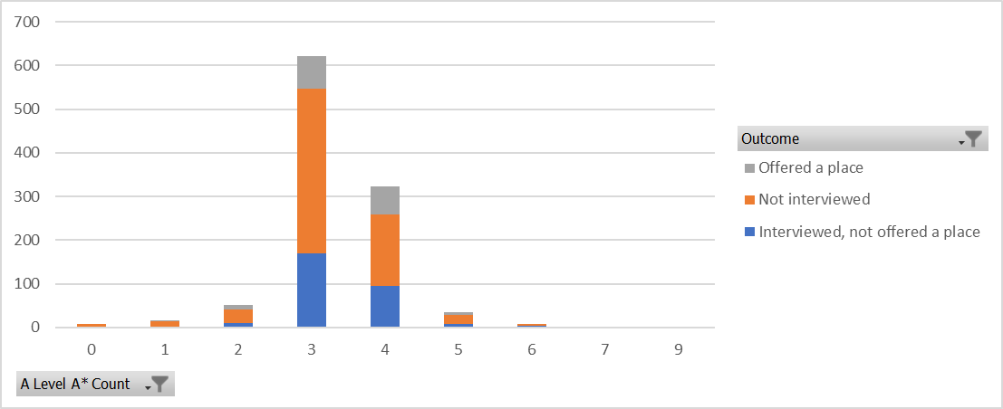

TSA Problem Solving

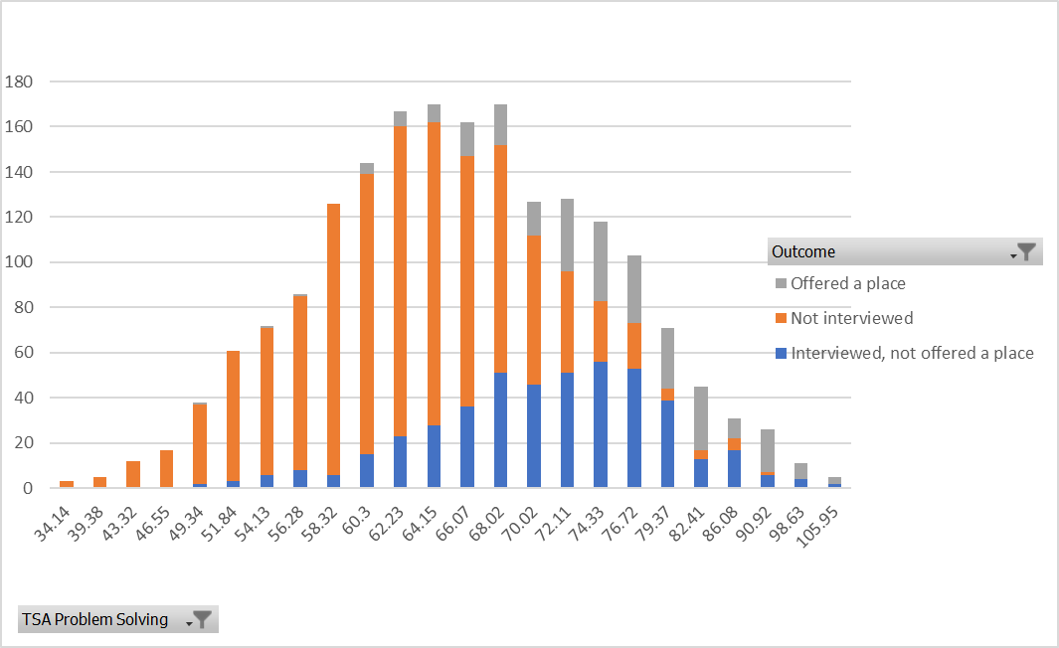

TSA Critical Thinking

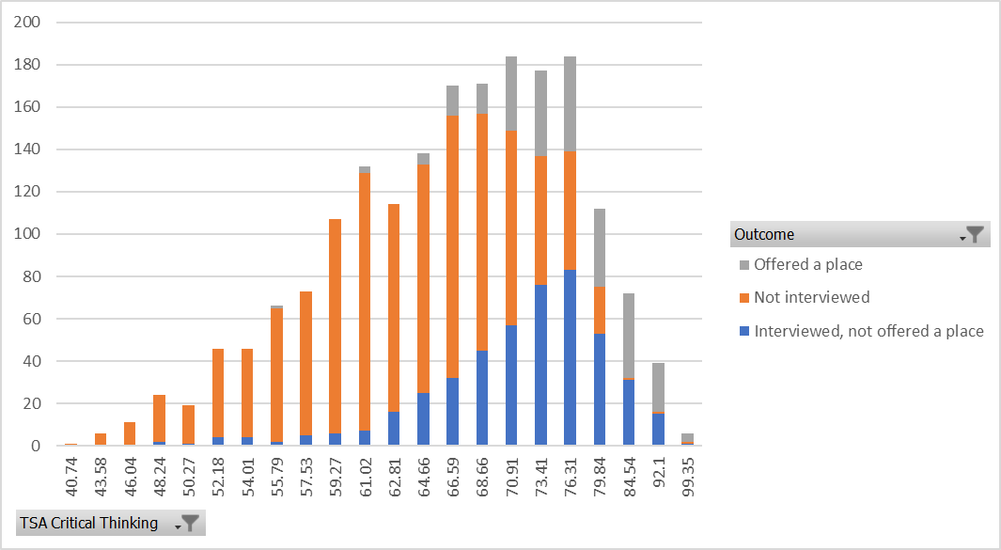

TSA Essay

