Statistics from the 2016 PPE Admissions Round
For 2017 Entry

In 2016 we received 1983 applications for PPE (as at 24 October 2016: some applicants had withdrawn before this point). 705 applicants (36%) were shortlisted for interview. 274 offers of places were made (including Open Offers and Deferred Offers). 14% of all applicants, and 39% of shortlisted applicants, were successful. 1913 (96.5%) applicants successfully registered for and sat the TSA admissions test. 0 applicants who had not sat the TSA were interviewed and offered a place. 53 applicants applied for deferred entry. Of these, 22 were interviewed and 5 received an offer for 2018.

1 Shortlisting
The factors involved in shortlisting applicants have the following levels of importance:
- High Importance: TSA; GCSE (or similar) profile; predicted performance at A Level (or equivalent)
- Medium Importance: UCAS reference
- Low Importance: AS Level module grades (or equivalent); UCAS personal statement

Admissions tutors use the full set of information on GCSE performance, including A and A* grades. They also use GCSE performance data for schools in Great Britain and Northern Ireland to assess whether an applicant's grades reflect an under- or over-performance within the context of the school at which they were taken. Therefore, the chance of being short-listed may be increased/reduced if an applicant has a higher/lower proportion of A* grades than would be predicted for the average student applying to Oxford from their school.

Figure 1 shows the distribution of the marks in each component of the TSA for applicants who were not interviewed, those interviewed but not offered a place, and those offered a place.

Figure 1: TSA Marks

(a) Problem Solving
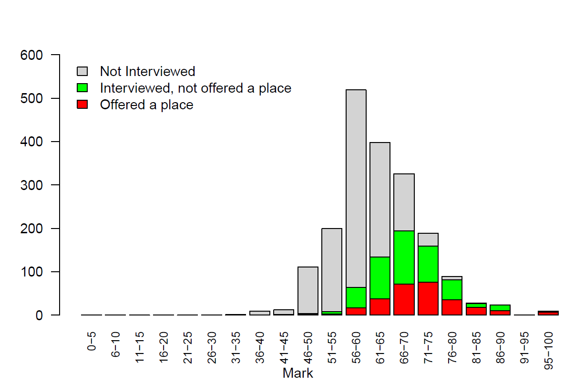

(b) Critical Thinking
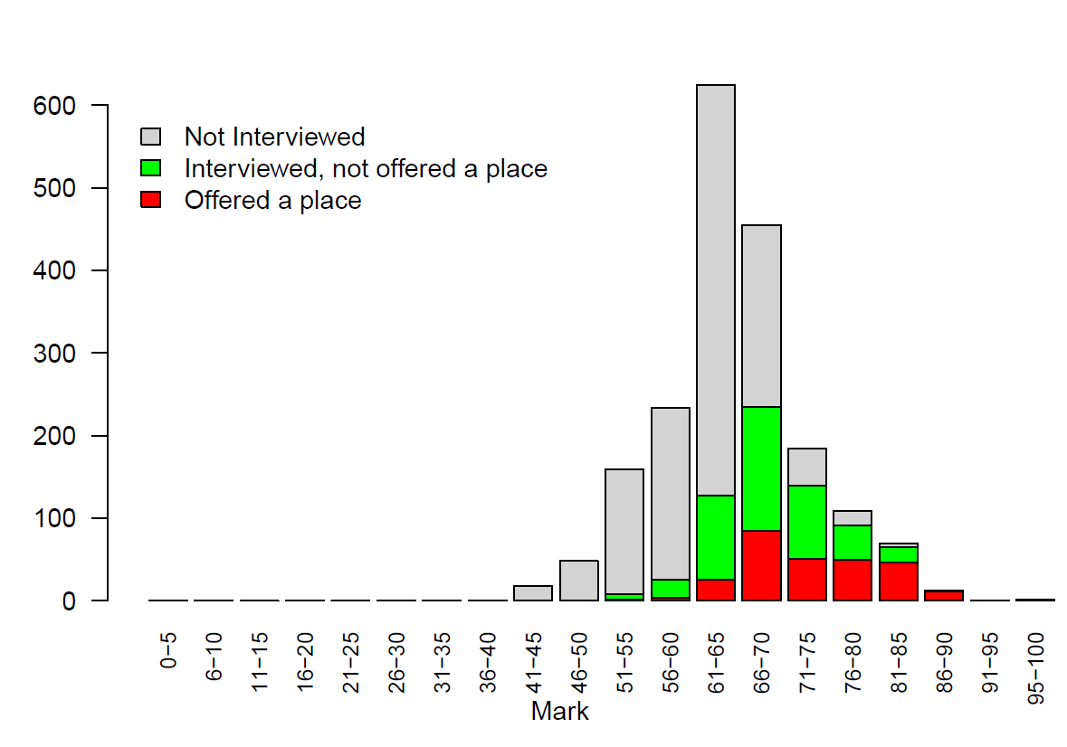

(c) Essay
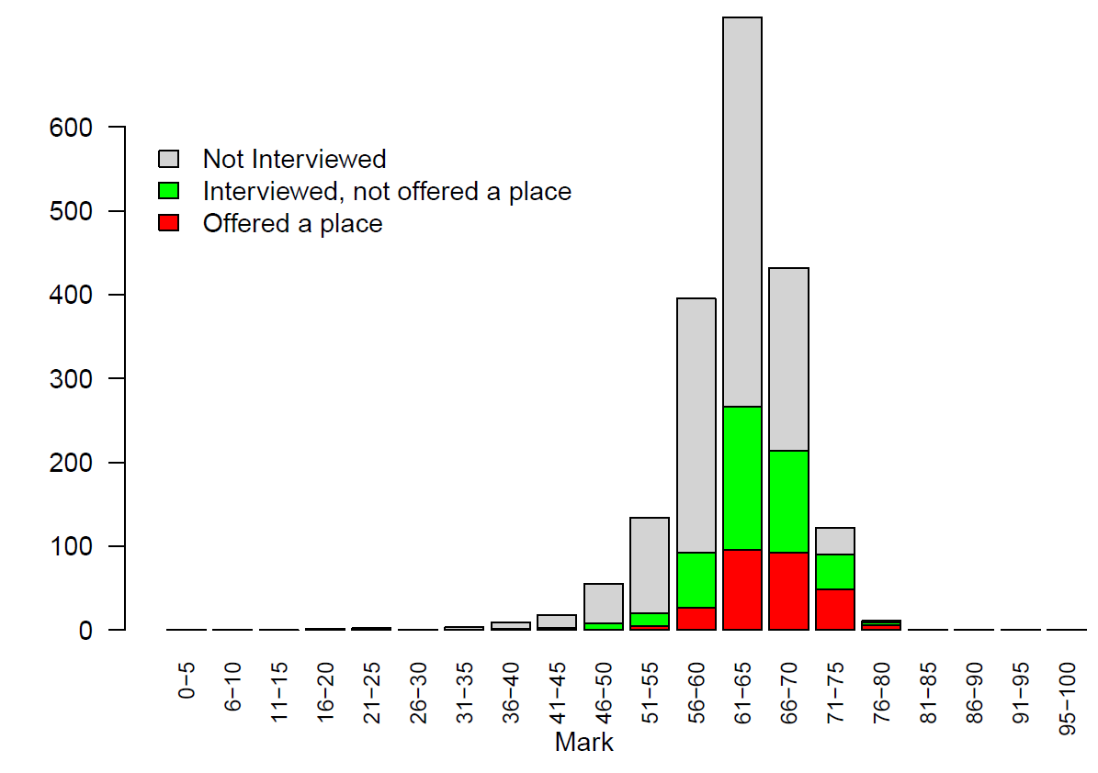

Figure 2 shows the distribution of the number of A's and A*'s (panel(a)) and A*'s (panel (b)) at GCSE for applicants who were not interviewed, those interviewed but not offered a place, and those offered a place.

Figure 2: GCSE Grades

(a) A and A* count

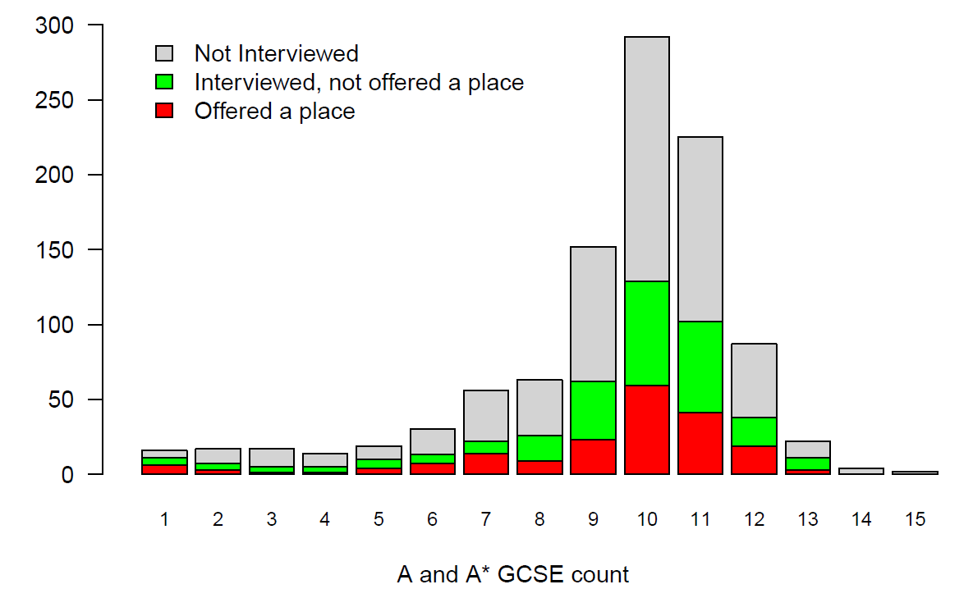

(b) A* count
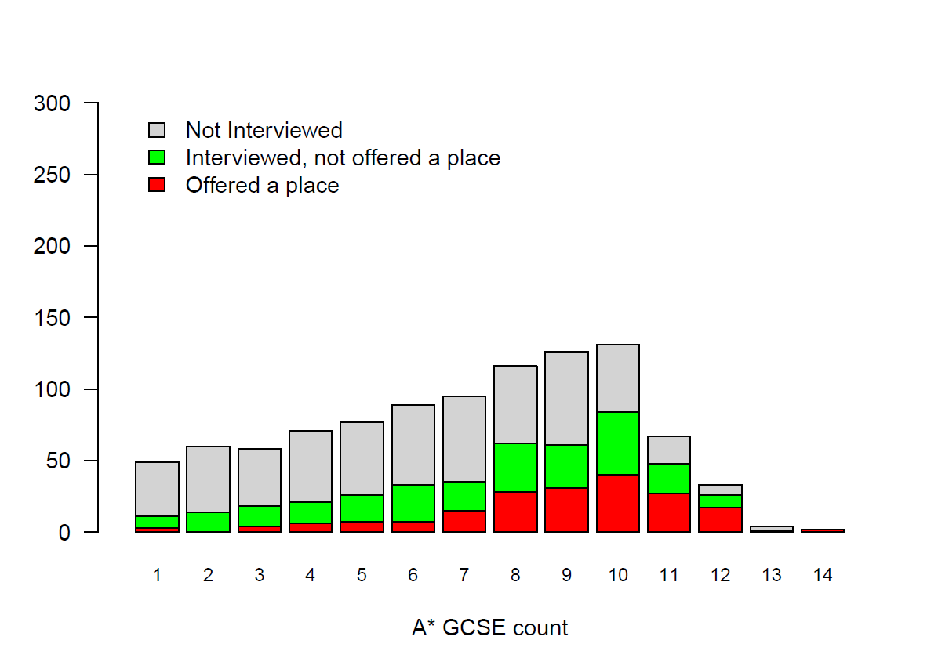

Figure 3 shows the distribution of the number of predicted A*'s at A-Level for applicants who were not interviewed, those interviewed but not offered a place, and those offered a place.

Figure 3: Predicted A-Level Grades

A* count
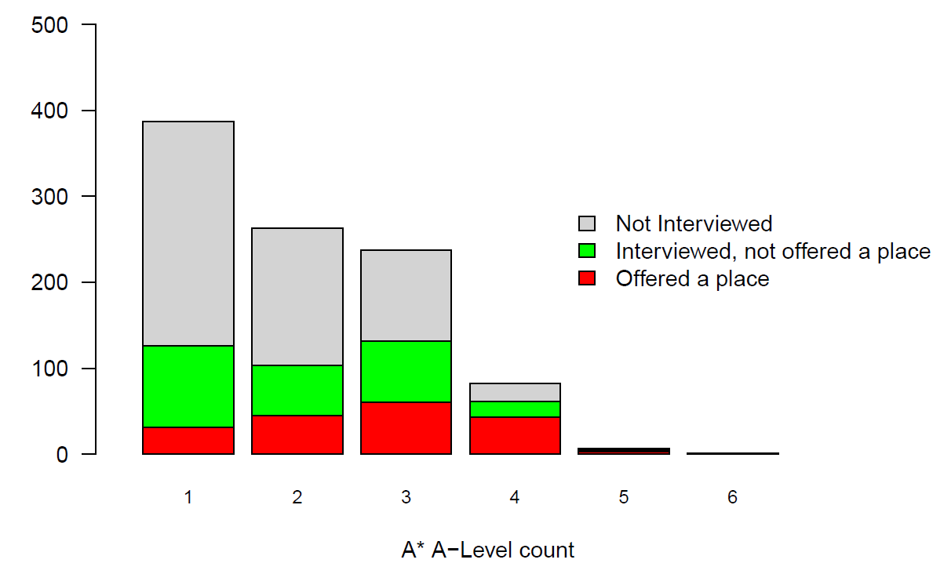

2 Interviews & Offers
The characteristics being judged in interview are:
- Application and interest: capacity for sustained study, motivation and interest, an independent and reflective approach to learning;
- Reasoning ability: ability to analyse and solve problems using logical and critical approaches, ability to assess relevance, capacity to construct and critically assess arguments, flexibility and willingness to consider alternative views;
- Communication: willingness and ability to express ideas clearly and effectively on paper and orally; ability to listen; ability to give considered responses.

3 A-level Subjects
977 (49%) applicants offered A-levels. Applicants for PPE may have done any combination of subjects at school. History and Mathematics are useful backgrounds, but are considered not essential.

Mathematics

Although a background in Mathematics is not formally required for admission, PPE applicants should have sufficient interest in, and aptitude for, mathematics to cope with the mathematical elements of the course. Mathematics is a particular advantage for the Economics component of the course, as well as for the first year logic course in Philosophy, and for understanding theories and data in Politics.

Of the 977 applicants offering A-Levels, 798 had Mathematics (or Maths and Further Maths). Of the 428 applicants offering A-Levels who were interviewed, 380 (89%) had Mathematics. Of the 183 applicants offering A-Levels who were awarded a place, 170 (93%) had Mathematics.

The following diagrams show the distribution of marks in the three components of the TSA for A-Level applicants with and without A-Level Maths. The average marks for A-Level applicants with Mathematics were 63.6, 66.1, and 63.5 in the Problem Solving, Critical Thinking, and Essay components respectively. For A-Level applicants without Mathematics, the average marks were 62.4, 64.7, and 62.5.

Figure 4: TSA Marks

(a) Problem Solving
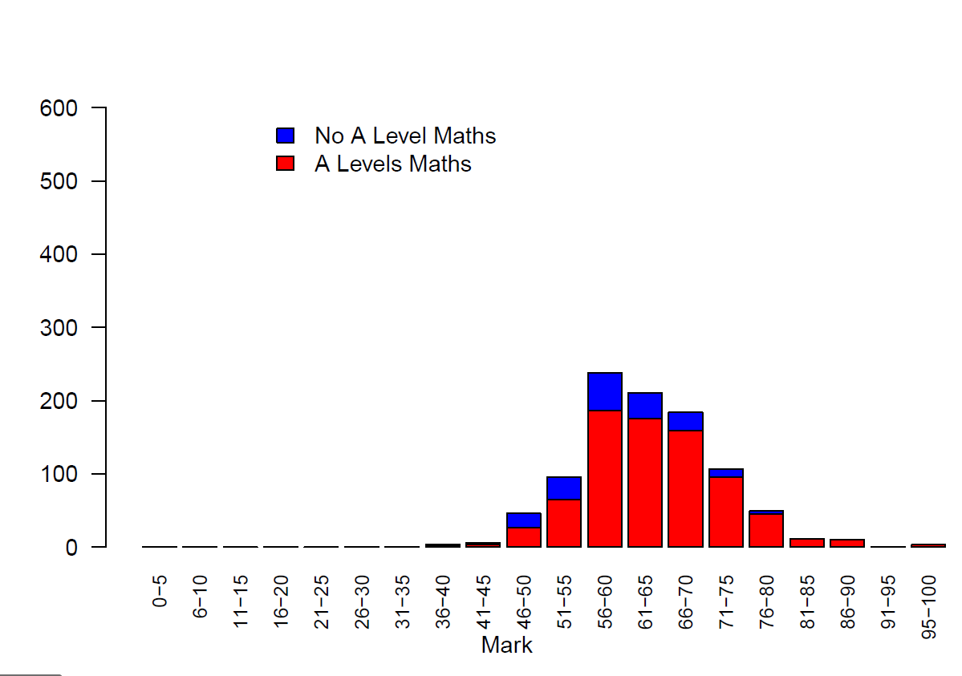

(b) Critical Thinking
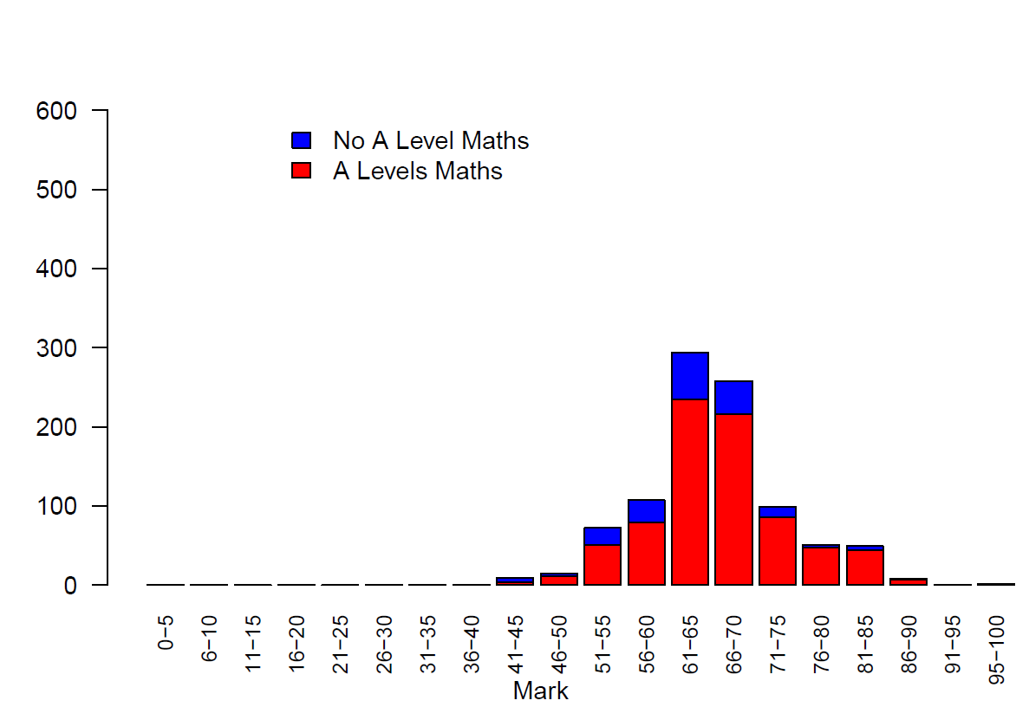

(c) Essay
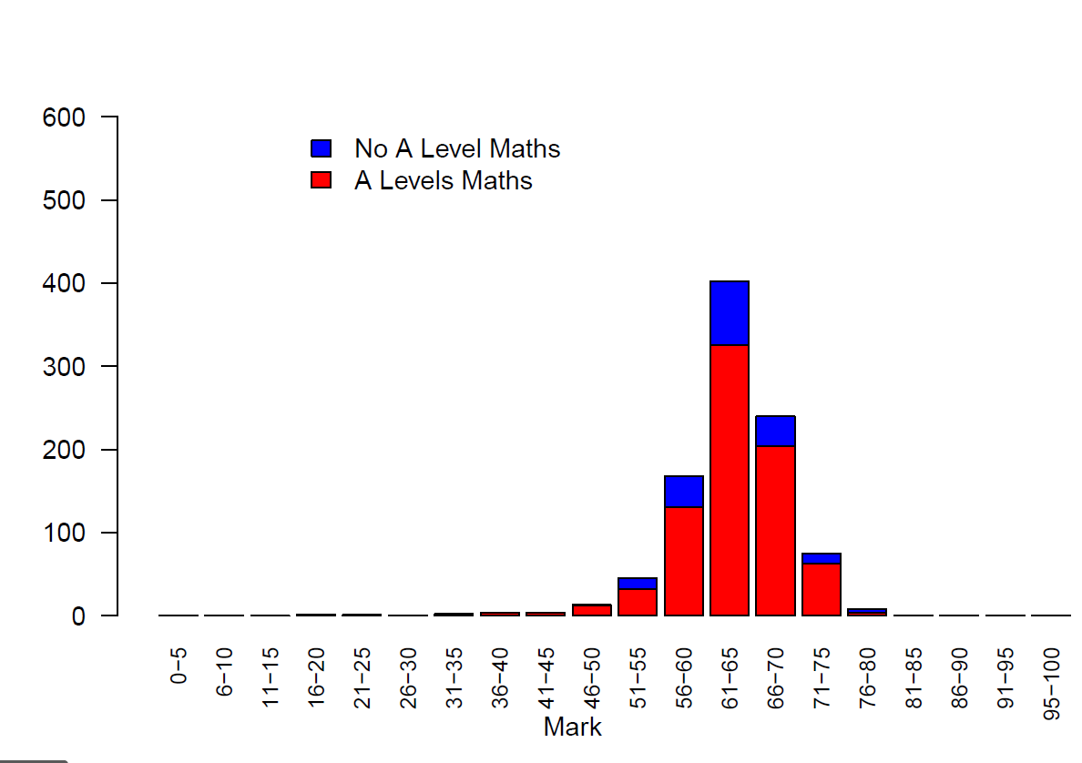

History
Of the 977 applicants offering A-Levels, 435 had A-Level History. Of the 428 applicants offering A-Levels who were interviewed, 205 (48%) had History. Of the 183 applicants offering A-Levels who were awarded a place, 94 (51%) had History.

PPE
739 applicants offered at least one A-Level in either Philosophy, Politics/Government, or Economics. Of the 183 applicants offering A-Levels who were awarded places, 141 (77%) had at least one of these subjects. Economics was the most popular of these subjects. It was offered by 601 applicants of the 977 studying A-Levels (62%) and by 107 (58%) of those 183 awarded places. Politics/Government was offered by 288 applicants, and Philosophy by 37 applicants. 5 applicants offered A-Levels in all three subjects.

4 International Applicants
There were 605 (31%) non-EU international applicants. Of these, 175 were shortlisted for interview, and 53 were offered places.

Figure 5: TSA Marks

(a) Problem Solving
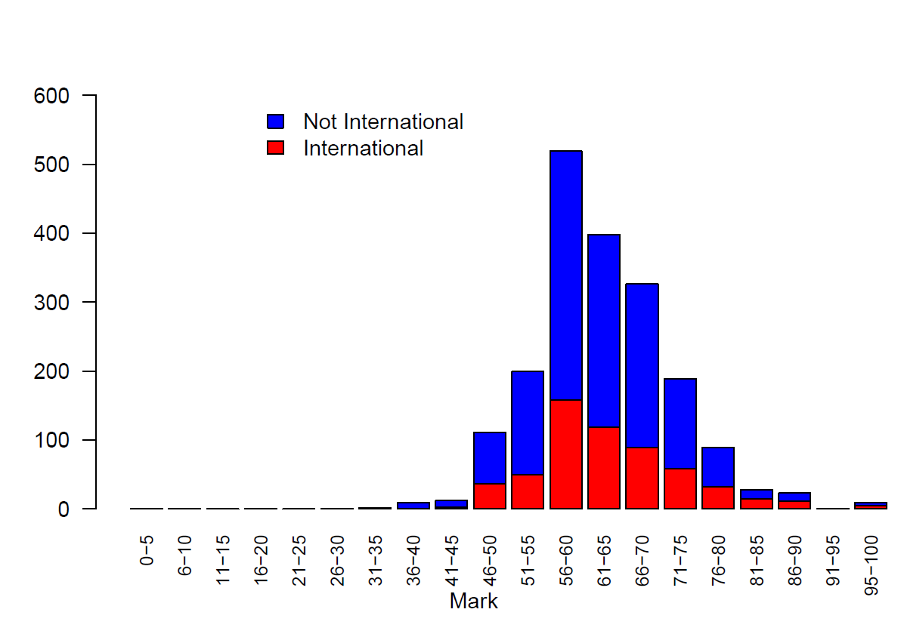

(b) Critical Thinking
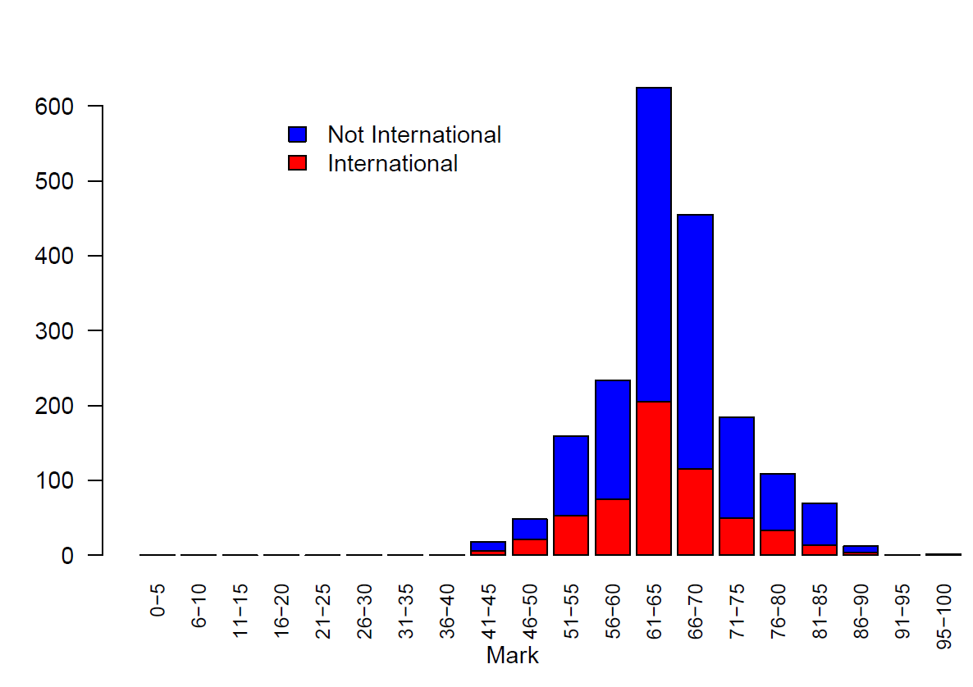

(c) Essay
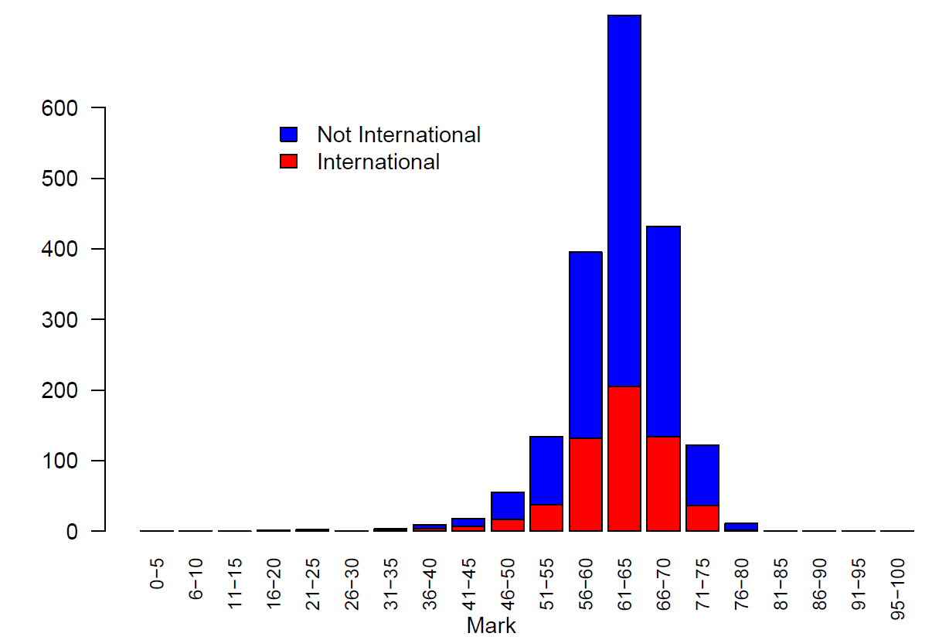

Applicants awarded Open Offers are guaranteed a place, subject to the conditions attached to the offer. However, their college is not decided until after exam results are released.
Applicants awarded Deferred Offers are guaranteed a place, subject to the conditions of the offer, but start the course a year later than applicants awarded normal offers.

